# VISVESVARAYA TECHNOLOGICAL UNIVERSITY

**“Jnana Sangama”, Belagavi-590018**

**A DBMS Lab Mini Project Report On**

**“IRCTC RAILWAY RESERVATION”**

**SUBMITTED IN PARTIAL FULFILLMENT FOR 5TH SEMESTER**

**BACHELOR OF ENGINEERING IN**

**COMPUTER SCIENCE AND ENGINEERING**

**SUBMITTED BY**

## Shashidhar A S (1JB20CS113)

## Suchith Kumar G M(1JB20CS113)

**Under the Guidance of**

**Mrs. Prakruthi M K**

**Assistant Professor**

**Dept. of CSE,**

**SJBIT, Bengaluru-560060**

**SJBIT**

**DEPARTMENT OF COMPUTER SCIENCE AND ENGINEERING**

**SJB INSTITUTE OF TECHNOLOGY**

No.67, BGS Health & Education City, Dr.Vishnuvardhan Rd, Kengeri,

Bengaluru, Karnataka 560060

## 2022 - 2023

­­­

**|| Jai Sri Gurudev ||**

## Sri Adichunchanagiri Shikshana Trust ®

**SJB INSTITUTE OF TECHNOLOGY**

No.67, BGS Health & Education City, Dr.Vishnuvardhan Rd, Kengeri, Bengaluru, Karnataka 560060

# Department of Computer Science and Engineering



**SJBIT**

**CERTIFICATE**

Certified that the Mini Project Work entitled “IRCTC RAILWAY RESERVATION” carried out by Mr. **SHASHIDHAR A S** & Mr. **SUCHITH KUMAR G M** bearing USN **1JB20CS113** & **1JB20CS124** are bonafide students of **SJB Institute of Technology** in partial fulfilment for 5th semester of **ENGINEERING** in **Computer Science and Engineering** of the **Visvesvaraya Technological University**, **Belagavi during** the academic year **2022-23.** It is certified that all corrections/ suggestions indicated for Internal Assessment have been incorporated in the Report deposited in the Departmental library. The project report has been approved as it satisfies the academic requirements in respect of Project work phase-1 prescribed for the said Degree.

Signature of Guide

Signature of HOD

**Mrs. Prakruthi M K**

Assistant Professor

Dept. of CSE, SJBIT

**Dr. Krishna A N** Professor & Head Dept. of CSE, SJBIT

## 1. Internal Examiner: _________________________

2. **External Examiner: _________________________**

i





**ACKNOWLEDGEMENT**

We would like to express our profound grateful to His Divine Soul **Jagadguru Padmabhushan Sri Sri Sri Dr. Balagangadharanatha Mahaswamiji** and His Holiness **Jagadguru Sri Sri Sri Dr. Nirmalanandanatha Mahaswamiji** for providing us an opportunity to complete our academics in this esteemed institution.

We would also like to express our profound thanks to Revered **Sri Sri Dr. Prakashnath Swamiji**, Managing Director, SJB Institute of Technology, for his continuous support in providing amenities to carry out this Mini Project Work in this admired institution.

We express our gratitude to **Dr. K. V. Mahendra Prashanth**, Principal, SJB Institute of Technology, for providing us an excellent facilities and academic ambience; which have helped us in satisfactory completion of Mini Project Work.

We extend our sincere thanks to **Dr. Krishna A N**, Head of the Department, Computer Science and Engineering for providing us an invaluable support throughout the period of our Mini Project Work.

We wish to express our heartfelt gratitude to our guide **Mrs. Prakruthi M K**, Assistant Professor, Dept. of CSE, for her valuable guidance, suggestions and cheerful encouragement during the entire period of our Mini Project Work.

Finally, we take this opportunity to extend our earnest gratitude and respect to our parents, Teaching & Non-teaching staffs of the department, the library staff and all our friends, who have directly or indirectly supported us during the period of our Mini Project Work.

ii

Regards,

Shashidhar AS(1JB20CS113)

Suchith Kumar GM(1JB20CS113)

**ABSTRACT**

Indian Railway Catering and Tourism Corporation popularly known as **IRCTC** is an Indian public sector undertaking that provides ticketing, catering, and tourism services for the Indian Railways.

Our project "IRCTC railway reservation" is a desktop based stand alone application developed using java swings framework of java.This project is an attempt to demostrate the working of railway reservation process both from the admin and user view.

This project provides various functionalities to the user where he can create his own account or login through an existing account and search the desired trains according to plan of his/her travel.The user can also book the seats to confirm his travel in the indian railways.

Other functionalities includes viewing his profile,view his previous bookings. passengers travelling in the train are assigned a pnr number which is unique and find all the details of their journey by using the search pnr function.The user also receives a confirmation mail to his registered mail id after booking.All the details are stored in the database which is accessed dynamically everytime to provide accurate information.

It also has admin where the admin is authenticated using both password and OTP sent to his registered mail providing two step verification.The admin can make major changes which includes adding a new train to the database.

iii

**TABLE OF CONTENTS**

Certificate i

Acknowledgement ii

Abstract iii

Table of contents iv-v

List of Figures v

**SL. NO CHAPTER TOPIC PAGE NO.**

**1 Introduction 1-7**

* 1. Introduction to the project
  2. Project Objective
  3. Project Scope
  4. Introduction to Database

1.41 Advantages of Database

1.42 Components of Database

1.5 Constraints

1.6 Normalization

**2 Related Work 8**

2.1 Existing System

2.2 Proposed System

**3** **System Design 9-13**

3.1 Requirements and Constraints

3.2 ER Diagram

3.3 Relational Schema

**4 Implementation 14-17**

4.1 Software Requirements

4.2 Hardware requirements

4.3 Code Snippets

**SL NO.**  **CHAPTER TOPIC PAGE NO.**

### **5** Testing and Results 18-29

5.1.1 Testing Process

5.1.2 Unit testing

5.1.3 Integration testing

5.1.4 System testing

5.2 Snapshots

6  **Conclusion and future scope**   **30**

**References**   **31**

iv

|  |  |  |  |
| --- | --- | --- | --- |
| **SL. NO** | **CHAPTER** | **TOPIC** | **PAGE NO.** |
| **1** | **Introduction** | 1.1 Introduction to the project | **1-5** |
|  |  | 1.2 Project Objective |  |
|  |  | 1.3 Project Scope |  |
|  |  | 1.4 Introduction to Database |  |
|  |  | 1.4.1 Advantages of Database |  |
|  |  | 1.4.2 Components of Database |  |
|  |  |  |  |
| **2** | **Related Work** | 2.1 Existing System | **6-7** |
|  |  | 2.2 Proposed System |  |
| **3** | **System Design** | 3.1 Requirements and Constraints | **8-12** |
|  |  | 3.2 ER Diagram |  |
|  |  | 3.3 Relational Schema |  |
|  |  |  |  |
| **4** | **Implementation** | 4.1 Software Requirements | **13-16** |
|  |  | 4.2 Hardware Requirements |  |
|  |  | 4.3 Code Snippets |  |
|  |  |  |  |
|  |  |  |  |
|  |  |  |  |

|  |  |  |  |
| --- | --- | --- | --- |
| **SL NO.** | **CHAPTER** | **TOPIC** | **PAGE NO.** |
| **5** | **Testing and Results** | 5.1 Testing | **17-28** |
|  |  | 5.1.1 Testing Process |  |
|  |  | 5.1.1 Unit testing |  |
|  |  | 5.1.3 Integration testing |  |
|  |  | 5.1.4 System testing |  |
|  |  | 5.2 Snapshots |  |
| **6** | **Conclusion and future scope** |  | **29** |
|  | **References** |  | **30** |

**v**

IRTC Railway Reservation

**CHAPTER 1**

**INTRODUCTION**

* 1. **INTRODUCTION TO PROJECT**

Indian Railway Catering and Tourism Corporation popularly known as IRCTC is an Indian public sector undertaking that provides ticketing, catering,and tourism services for the Indian Railways.

Our project "IRCTC railway reservation" is a desktop based stand alone application developed using java swings framework of java.

This project is an attempt to demonstrate the working of railway reservation process both from the admin and user view.all the functionalities which are provided by the irctc website and app are implemented in the form of desktop application which is very simple and easy to use.

The user interface is attracting and doesn't confuse users in completing their booking process.

* 1. **PROJECT OBJECTIVE**

The main objective of the project is to implement the desktop version of IRCTC mobile application which provides all the functionalities in desktop.

A complete and efficient desktop application which can provide a good and user friendly experience is the basic objective of the project.

* 1. **PROJECT OVERVIEW**

The central concept of the application is to allow the users to book tickets virtually using the Internet.The information pertaining to the trains ,stations ,cost,time and all other necessary details are stored in the database in the form of tables following the rules of RDBMS(Relational database management system).

The application process the users request and sends the ticket to their registered e-mail id where the user doesn't need any hard copy of the ticket to travel in the train.The application is designed into two modules ,first is for the users who wish to book the tickets.Second is for the admin who maintains and updates the information pertaining to the trains and their respective schedules and even those of the customers. The end user of this product is the customer where the application is hosted on the desktop as stand alone and the administrator maintains the database.

The application which is deployed at the user database, the details of the trains and personal information are brought forward from the database for the user view based on the selection through the menu and the database of all the trains such as updating the available seats after each booking and updating the bookings table after each booking is completed successfully.Data entry into the application can be done through various screens designed for various levels of end users(admin and customer).

Department of Computer Science, SJBIT 2022-23 Page 1

IRTC Railway Reservation

**1.4 PROJECT SCOPE**

This system can be implemented in any desktop which complete the requirements in order to user the application.The system recommends a facility to accept the bookings 24*7 and online ticket issuing system which decreases the effort of customers to take the offline ticket issued at the station.

This system also decreases the effort of the railways to appoint more employee to issue tickets.

The railways also doesn't loose their customers and even are also happy by their decrease of effort.Since the application is available in the desktop it is easily accessible and always available.

PNR status is one of the important feature where the users can track their booking status by entering their 10 digit number which shows all the details of the passengers travelling in the booked train which also shows the seat number which can be updated when their is some changes in the operation of the train.

#### **1.5 INTRODUCTION TO DATABASE**

Databases and database technology have had a major impact on the growing use of computers. A database is a collection of related data. By data, we mean known facts that can be recorded and that have implicit meaning. For example, consider the names, telephone numbers, and addresses of the people you know. Nowadays, this data is typically stored in mobile phones, which have their own simple database software. In other words, a database has some source from which data is derived, some degree of interaction with events in the real world, and an audience that is actively interested in its contents. A database can be of any size and complexity. For example, the list of names and addresses referred to earlier may consist of only a few hundred records, each with a simple structure. On the other hand, the computerized catalogue of a large library may contain half a million entries organized under different categories.

A database has the following implicit properties:

* A database represents some aspect of the real world, sometimes called the mini world or the universe of discourse. Changes to the mini world are reflected in the database.
* A database is a logically coherent collection of data with some inherent meaning. A random assortment of data cannot correctly be referred to as a database.
* A database is designed, built, and populated with data for a specific purpose. It has an intended group of users and some preconceived applications in which these users are interested.

A database management system (DBMS) is a computerized system that enables users to create and maintain a database. The DBMS is a general-purpose software system that facilitates the processes of defining, constructing, manipulating, and sharing databases among various users and applications. Defining a database involves specifying the data types, structures, and constraints of the data to be stored in the database. The database definition or descriptive information is also stored by the DBMS in the form of a database catalogue or dictionary; it is called meta-data. Constructing the database is the process of storing the data on some storage medium that is controlled by the DBMS. Sharing a database allows multiple users and programs to access the database simultaneously.

Department of Computer Science, SJBIT 2022-23 Page 2

IRCTC Railway Reservation

**1.5.1 ADVANTAGES OF DBMS:**

Compared to the File Based Data Management System, Database Management System has many advantages.

##### **1.Reducing Data Redundancy**

The file-based data management systems contained multiple files that were stored in many different locations in a system or even across multiple systems. Because of this, there were sometimes multiple copies of the same file which leads to data redundancy. This is prevented in a database as there is a single database and any change in it is reflected immediately. Because of this, there is no chance of encountering duplicate data.

##### **2.Data Integrity**

Data integrity means that the data is accurate and consistent in the database. Data Integrity is very important as there are multiple databases in a DBMS. All of these databases contain data that is visible to multiple users.

So, it is necessary to ensure that the data is correct and consistent in all the databases and for all the users.

##### **3.Data Security**

Data Security is vital concept in a database. Only authorised users should be allowed to access the database and their identity should be authenticated using a username and password. Unauthorised users should not be allowed to access the database under any circumstances as it violates the integrity constraints.

##### **4.Privacy**

The privacy rule in a database means only the authorized users can access a database according to its privacy constraints. There are levels of database access and a user can only view the data he is allowed to. For example - In social networking sites, access constraints are different for different accounts a user may want to access.

##### **5.Backup and Recovery**

Database Management System automatically takes care of backup and recovery. The users don't need to backup data periodically because this is taken care of by the DBMS. Moreover, it also restores the database after a crash or system failure to its previous condition.

##### **6.Data Consistency**

Data consistency is ensured in a database because there is no data redundancy. All data appears consistently across the database and the data is same for all the users viewing the database. Moreover, any changes made to the database are immediately reflected to all the users and there is no data inconsistency.

Department of Computer Science, SJBIT 2022-23 Page 3

IRTC Railway Reservation

##### **1.5.2 COMPONENTS OF DBMS**

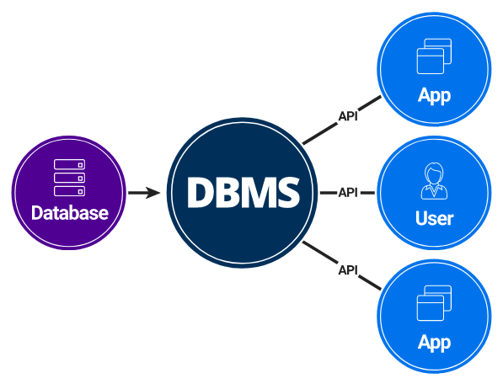

**Fig 1.1 Components of DBMS**

The figure 1.1 shows the components of DBMS which describe the different parts that work together for creating, managing the database that forms a complete system named DBMS(database management system).

* **Users**:

Users may be of any kind, such as data base administrators, system developers or database users.

* **Database application**:

Database application may be Departmental, Personal, Organizational and /or Internal.

* **DBMS**:

Software that allows users to create and manipulate database access.

* **Database**:

Collection of logical data as a single unit.

Department of Computer Science, SJBIT 2022-23 Page 4

IRCTC Railway Reservation

##### **1.5.3 INDICATIVE AREAS FOR THE USE OF DBMS**

|  |  |
| --- | --- |
| **SECTOR** | **USE OF DBMS** |
| **BANKING** | For customer information, account activities, payments, deposits, loans, etc. |
| **AIRLINES** | For reservations and schedule information. |
| **UNIVERSITIES** | For student information, course registrations, colleges, and grades. |
| **TELECOMMUNICATION** | It helps to keep call records, monthly bills, maintaining balances, etc. |
| **FINANCE** | For storing information about stock, sales, and purchases of financial instruments like stocks and bonds. |
| **SALES** | Use for storing customer, product & sales information. |
| **MANUFACTURING** | It is used for the management of supply chain and for tracking production of items. Inventories status in warehouses |
| **HR MANAGEMENT** | For information about employees, salaries, payroll, deduction, generation of pay checks, etc |

**Table 1.1 Indicative areas for the use of DBMS**

**1.6 CONSTRAINTS**

Mainly Constraints on the relational database are of 4 types:

* Domain constraints
* Key constraints
* Entity Integrity constraints
* Referential integrity constraints

Department of Computer Science, SJBIT 2022-23 Page 5

IRCTC Railway Reservation

**DOMAIN CONSTRAINTS:**

* Every domain must contain atomic values (smallest indivisible units) it means composite and multivalued attributes are not allowed.
* We perform datatype check here, which means when we assign a data type to a column we limit the values that it can contain.
* Eg. If we assign the datatype of attribute age as int, we can’t give it values other than int datatype.

**KEY CONSTRAINTS OR UNIQUENESS CONSTRAINTS:**

* These are called uniqueness constraints since it ensures that every tuple in the relation should be unique.
* A relation can have multiple keys or candidate keys(minimal superkey), out of which we choose one of the keys as primary key, we don’t have any restriction on choosing the primary key out of candidate keys, but it is suggested to go with the candidate key with less number of attributes.
* Null values are not allowed in the primary key, hence Not Null constraint is also a part of key constraint.

**ENTITY INTEGRITY CONSTRAINTS**:

Entity Integrity constraints says that no primary key can take NULL value, since using primary key we identify each tuple uniquely in a relation.

**REFERENTIAL INTEGRITY CONSTRAINTS:**

* The Referential integrity constraints is specified between two relations or tables and used to maintain the consistency among the tuples in two relations.
* This constraint is enforced through foreign key, when an attribute in the foreign key of relation R1 have the same domain(s) as the primary key of relation R2, then the foreign key of R1 is said to reference or refer to the primary key of relation R2.
* The values of the foreign key in a tuple of relation R1 can either take the values of the primary key for some tuple in relation R2, or can take NULL values, but can’t be empty.

Department of Computer Science, SJBIT 2022-23 Page 6

IRCTC Railway Reservation

**1.6 NORMALISATION**

Normalizing tables accordingly based on the normal forms.

**NORMAL FORMS:**

Of a relation refers to the highest normal form condition that it meets and hence indicates the degree to which it has been normalized.

* **First NF:**

States that the domain of the attribute must only include atomic values and the value of any attribute in a tuple must be a single value.

* **Second NF:**

Is based on the concept of full functional dependency I.e. if removal of any attribute A from X in FD X->Y the dependency does not hold anymore.

* **Third NF:**

A relation schema R is in 3NF if, whenever a non-trivial functional dependency X->A holds in R either: X is a super key of R or A is prime attribute of R.

* **Boyce-Codd NF:**

A relation schema R is in BCNF if whenever a non-trivial functional dependency X->A holds in R, then X is a super key of R.

* **Fourth NF:**

A relation schema R is in 4NF w.r.t a set of dependencies F if, for every non-trivial multivalued dependency X->>Y in F+ ,X is a super key for R.

Department of Computer Science, SJBIT 2022-23 Page 7

IRCTC Railway Reservation

**CHAPTER 2**

### **RELATED WORK**

System analysis is the process of gathering and interpreting facts, diagnosing problems and using the information to recommend improvements on the system. System analysis is a problem-solving activity that requires intensive communication between the system users and system developers. System analysis or study is an important phase of any system development process. The system is viewed as a whole, the inputs are identified and the system is subjected to close study to identify the problem areas. The solutions are given as a proposal. The proposal is reviewed on user request and suitable changes are made. This loop ends as soon as the user is satisfied with the proposal.

#### **2.1 EXISTING SYSTEM**

Existing system refers to the system being followed till now. The existing system requires more computational time, more manual calculations, and the complexity involved in the selection of the features is high. The other disadvantages are lack of security of data, deficiency of data accuracy, Time consuming etc. To avoid all these limitations and make the working more accurately the system needs to be computerized. A detailed study of existing systems is carried along with the steps in system analysis.

Drawbacks:

* Lack of security
* More man power
* Time consuming
* Needs annual calculations
* Consumes large volume of paperwork
* Damage of machines due to lack of attention

#### **2.2 PROPOSED SYSTEM**

The aim of the proposed system is to develop a system of improved facilities. The proposed system can overcome all the limitations of the existing system. The system provides proper security and reduces manual work. The existing system has several disadvantages and many more difficulties to work well. The proposed system will help the user to reduce the workload and mental conflict. The proposed system helps the user to work user friendly and he can easily do his job without time lagging.

Department of Computer Science, SJBIT 2022-23 Page 8

IRCTC Railway Reservation

**CHAPTER 3**

### **SYSTEM DESIGN**

#### **3.1 REQUIREMENTS AND CONSTRAINTS**

System design is the solution for the creation of a new system. This phase focuses on the details implementation of the feasible system and its emphasis on translating design.

System design has two phases:

● Logical design

● Physical design

During the logical design phase, the analyst describes inputs (sources), outputs(destinations), databases (data sores) and procedures (data flows) all in a format that meets the user requirements. The analyst also specifies the needs of the user at a level that virtually determines the information flow in and out of the system and the data resources. Here the logical design is done through data flow diagrams and database design.

The physical design is followed by physical design or coding. It produces the working system by defining the design specifications, which specify exactly what the candidate system must do. The programmers write the necessary programs that accept input from the user, perform on necessary processing of accepted data and produce the required report on a hard copy or display it on the screen.

##### **Database**

Databases are the storehouses of data used in the software systems. The data is stored in tables inside the database. Several tables are created for the manipulation of the data for the system. Two essential settings for a database are Normalization is a technique to avoid redundancy in the tables.

#### **3.2 ER DIAGRAM**

ER Diagram stands for Entity Relationship Diagram, also known as ERD, is a diagram that displays the relationship of entity sets stored in a database. In other words, ER diagrams help to explain the logical structure of databases. ER diagrams are created based on three basic concepts: entities, attributes and relationships.

ER Diagrams contain different symbols that use rectangles to represent entities, ovals to define attributes and diamond shapes to represent relationships.

Department of Computer Science, SJBIT 2022-23 Page 9

IRCTC Railway Reservation

**Fig 3.1 ER Diagram**

Department of Computer Science, SJBIT 2022-23 Page 10

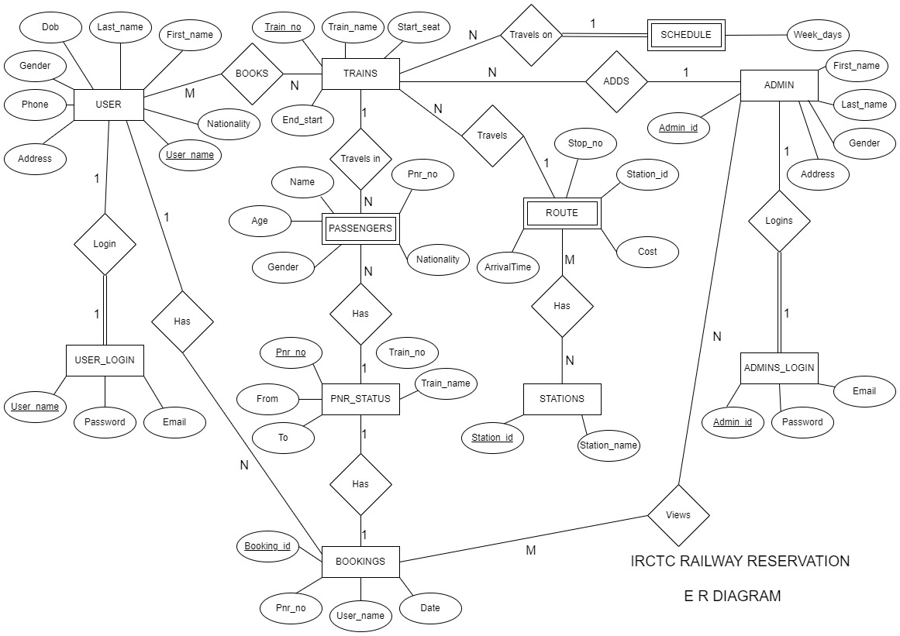

IRCTC Railway Reservation

**Fig 3.2 Relational Schema**

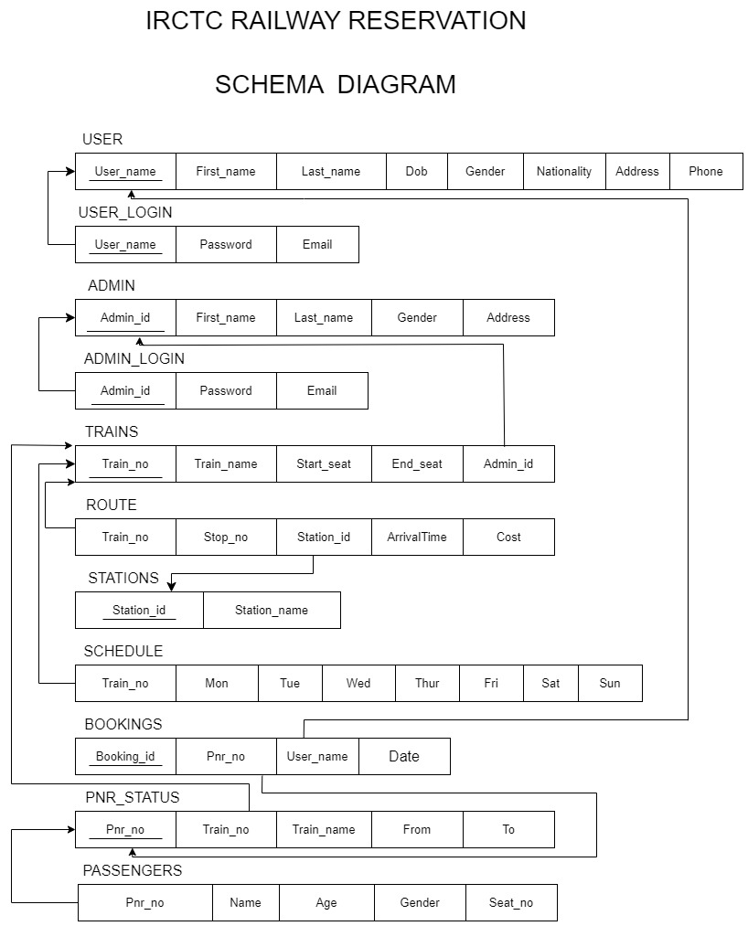

Department of Computer Science, SJBIT 2022-23 Page 11

IRCTC Railway Reservation

**CHAPTER 4**

### **IMPLEMENTATION**

#### **4.1 SOFTWARE REQUIREMENTS**

1. Operating System: Windows XP/VISTA/7/8/10/11

2. java SE 8 or higher

3. Any text editor supporting java compilation

4. MySql (workbench)

5. Full Administrator access

**4.2 HARDWARE REQUIREMENTS**

6. RAM:512 MB and above

7. HDD:500 MB and above

8. PROCESSOR: Intel® Core™ i5-8250U CPU @ 1.6GHz 1.80GHz

9. SYSTEM TYPE: 64-bit operating system, x64-based processor

**3.1 FUNCTIONAL REQUIREMENTS**

Various functional modules can be implemented by the system. it provides a requirement overview of the system.

The basic functionalities are differentiated by user and admin

**user-**

1. user registration - new user can register their account in IRCTC by providing their personal details like name,date of birth email,address etc.Email id is used for authentication using otp and for receiving online ticket copy.Each user is distinguished with the help of username which is unique for all the customers.

2.user login - Existing users can login into their account using username and password.

once user has logined he can access all the funcitonalities of the user.

3. search trains - users can enter the source and destination of their travel and then he gets a list of all the trains which travel in the given source and destinations and use can choose any train as per his choice.

4. book tickets - after searching the trains ,the details of the train are displayes and users can add passengers and then confirm his ticket booking with OTP authentication.

5. Bookings - user can view all his bookings

6. PNR status - user can check the passengers details using the pnr alloted to them at the time of booking.

7. profile - user after logging in ,can view their profile which contains all their details entered at the time of registering their account.(same for both user and admin)

Department of Computer Science, SJBIT 2022-23 Page 12

IRCTC Railway Reservation

**Admin---**

1. admin login- admin can login to their account using admin id and their password.admin is also authenticated using otp to their email to provide more security to admin as he can make major changes to the system.

2. add trains - admin can add a new train where he provides the train number ,name ,seats and route of travel of the train.

3. view bookings - admin can view all the bookings made by all the users .he can also view the username for all bookings made

logout- after performing the actions the user and admin can logout their session .

**4.1 TECHNOLOGIES USED IN BUILDING THE PROJECT**

**4.1.1 JAVA**

Java is a widely used object-oriented programming language and software platform that runs on billions of devices, including notebook computers, mobile devices, gaming consoles, medical devices and many others. The rules and syntax of Java are based on the C and C++ languages.

One major advantage of developing software with Java is its portability. Once you have written code for a Java program on a notebook computer, it is very easy to move the code to a mobile device. When the language was invented in 1991 by James Gosling of Sun Microsystems (later acquired by Oracle), the primary goal was to be able to "write once, run anywhere."

It's also important to understand that Java is much different from JavaScript. Javascript does not need to be compiled, while Java code does need to be compiled. Also, Javascript only runs on web browsers while Java can be run anywhe

**4.1.2 AWT**

The Java programming language class library provides a user interface toolkit called the Abstract Windowing Toolkit, or the AWT. The AWT is both powerful and flexible. Newcomers, however, often find that its power is veiled. The class and method descriptions found in the distributed documentation provide little guidance for the new programmer. Furthermore, the available examples often leave many important questions unanswered. Of course, newcomers should expect some difficulty. Effective graphical user interfaces are inherently challenging to design and implement, and the sometimes complicated interactions between classes in the AWT only make this task more complex. However, with proper guidance, the creation of a graphical user interface using the AWT is not only possible, but relatively straightforward.

This article covers some of the philosophy behind the AWT and addresses the practical concern of how to create a simple user interface for an applet or application.

**4.1.3 Java swings**

Java Swing is a lightweight Java graphical user interface (GUI) widget toolkit that includes a rich set of widgets. It is part of the Java Foundation Classes (JFC) and includes several packages for developing rich desktop applications in Java.

Department of Computer Science, SJBIT 2022-23 Page13

IRCTC Railway Reservation

Swing includes built-in controls such as trees, image buttons, tabbed panes, sliders, toolbars, color choosers, tables, and text areas to display HTTP or rich text format (RTF). Swing components are written entirely in Java and thus are platform-independent.

Swing offers customization of the look and feel of every component in an application without making significant changes to the application code. It also includes a pluggable look and feel feature, which allows it to emulate the appearance of native components while still having the advantage of platform independence. This particular feature makes writing applications in Swing easy and distinguishes it from other native programs.

Swing was distributed as a downloadable library and has been included as a part of Java standard edition 1.2. Originally, the graphics library for Java, developed by Netscape Communication Corporation, was called Internet Foundation Classes (IFC). The first release of IFC was on December 16, 1996. The evolution of JFC can be traced back to 1997, when Sun Microsystems and Netscape Communication Corporation came up with the idea of merging IFC with other technologies.

**4.1.4 SQL**

SQL (Structured Query Language) is a domain-specific language used in programming and designed for managing data held in a relational database Management system(RDBMS), or for stream processing in a relational data stream management system (RDSMS). In comparison to older read/write APIs like [SAM or VSAM, SQL offers two main advantages : first, it introduced the concept of accessing many records with one single command; and second, it eliminates the need to specify how to reach a record, e.g. with or without an index. The scope of SQL includes data insert, query, update and delete, schema creation and modification, and data access control. Since then, the standard has been revised to include a larger set of features. definition language, data manipulation language, and data control language. The scope of SQL includes data insert, query, update and delete, schema creation and modification, and data access control. Although SQL is often described as, and to a great extent is, a declarative language (4GL),it also includes procedural elements.

SQL was one of the first commercial languages for Edgar F Codd's relational model, as described in his influential 1970 paper, "A Relational Model of Data for Large SharedDataBanks".91Despitenot entirely adhering to the relational model as described by Codd, it became the most widely used database language.

SQL became a standard of the American National Standards Institute(ANSI) in 1986 and of the International Organization for Standardization(ISO) in 1987. Since then, the standard has been revised to include a larger set of features. Despite the existence .of such standards, most SQL code is not completely portable among different data base systems without adjustments.

Department of Computer Science, SJBIT 2022-23 Page 14

IRCTC Railway Reservation

**4.2 TABLE CREATION**

SQL comprises both data definition and data manipulation languages. Using the data definition properties of SQL, one can design and modify database schema.

To create tables we first need a database,to create database we use

**CREATE DATABASE IRCTCPROJECT**;

to set it as active

**USE IRCTCPROJECT;**

**CREATE:** Creates new databases, tables and views from RDBMS.

**Syntax:** CREATE TABLE table_name(attributes list with their databytes);

CREATE TABLE COMMANDS:

create admin table

create table admin(

admin_id varchar(50) primary key,

first_name varchar(30),

last_name varchar(30),

gender varchar(20),

address varchar(50)

);

create admin login table

create table admin_login(

admin_id varchar(50) primary key,

password varchar(20),

email varchar(50),

foreign key (admin_id) references admin(admin_id) on delete cascade

);

create user table

create table user (

user_name varchar(50) primary key,

first_name varchar(30),

last_name varchar(30),

dob varchar(20),

gender varchar(20),

nationality varchar(30),

address varchar(50),

phone varchar(10)

);

Department of Computer Science, SJBIT 2022-23 Page15

IRTC Railway Reservation

create user login table

create table user_login (

user_name varchar(50) primary key,

password varchar(20),

email varchar(50),

foreign key (user_name) references user(user_name) on delete cascade

);

create trains table-->used to store train details

create table trains(

train_no varchar(10) primary key,

train_name varchar(50),

start_seat integer,

end_seat integer,

admin_id varchar(50),

foreign key(admin_id)references admin(admin_id)

);

create schedule table

create table schedule(

train_no varchar(10) primary key,

mon varchar(5),

tue varchar(5),

wed varchar(5),

thur varchar(5),

fri varchar(5),

sat varchar(5),

sun varchar(5),

foreign key (train_no) references trains(train_no) on delete cascade

);

create table stations

create table stations(

station_id varchar(10) primary key,

station_name varchar(50)

);

Create routes of all trains

create table `train_no` (

train_no varchar(10),

stop_no integer auto_increment primary key,

station_id varchar(10),

arrival_time varchar(20),

cost integer

);

Department of Computer Science, SJBIT 2022-23 Page16